February GATE Group: “BIG”
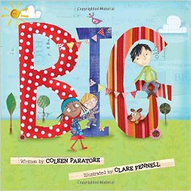
Our focus for this month’s GATE Group was around the reading of this children’s book by Coleen Paratore called: “BIG.”

A short synopsis:
“Follow three young friends, all different ages, as they figure out that being BIG isn’t measured by years, or weight, or inches. It’s being a friend to others. A friend to the Earth. A friend to yourself. Every day, in lots of little ways, they discover we all have the chance to be BIG!”

After reading and discussing this book, we took a “Field trip” around our school to discover any areas in our own building where we could demonstrate our
“BIG ness” to others.

Ask your children what they discovered about themselves, and how they were able to share the ways they could demonstrate how “BIG” they are in their own surroundings at NGES!

